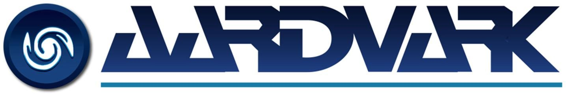
The Aardvark Group
51 Newall Terrace, Dumfries DG1 1LN. UNITED KINGDOM T: +44 (0) 1464 820122
E: info@aardvark.group

AARDVARK GROUP MODERN SLAVERY POLICY STATEMENT
Modern slavery is a crime and a violation of fundamental human rights. It takes various forms, such as slavery, servitude, forced and compulsory labour and human trafficking, all of which have in common the deprivation of a person's liberty by another in order to exploit them for personal or commercial gain.
The Aardvark Group (Aardvark Clear Mine Limited and subsidiaries) has a zero-tolerance approach to modern slavery and we are committed to acting ethically and with integrity in all our business dealings and relationships and to implement and enforce effective systems and controls to ensure modern slavery is not taking place anywhere in our own business or our supply chain.
Aardvark are also committed to ensuring there is transparency in our own business and in our approach to tackling modern slavery throughout our supply chain. Aardvark expects the same high standards from all of our contractors, suppliers and other business partners. As part of our contracting processes, we include specific prohibitions against the use of forced, compulsory or trafficked labour, or anyone held in slavery or servitude, and we expect that our suppliers will hold their own suppliers to the same high standards.
This policy applies to all persons working for us or on our behalf in any capacity, including employees at all levels, directors, officers, agency workers, seconded workers, volunteers, agents, contractors, external consultants, third-party representatives, and business partners. This policy does not form part of any employee’s contract of employment, and we may amend it at any time.

RESPONSIBILITY FOR THE POLICY
- The CEO has overall responsibility for ensuring this policy complies with our legal and ethical obligations, and that all those under our control comply with it.
- The Groups Directors have primary and day-to-day responsibility for implementing this policy, monitoring its use and effectiveness, dealing with any queries about it, and auditing internal control systems and procedures to ensure they are effective in countering modern slavery.
- Management at all levels are responsible for ensuring those reporting to them understand and comply with this policy and are given any required training.

COMPLIANCE WITH THE POLICY
- All Aardvark employees must ensure that they read, understand, and comply with this policy.
- The prevention, detection, and reporting of modern slavery in any part of our business or supply chain is the responsibility of all those working for us or under our control. You are required to avoid any activity that might lead to, or suggest, a breach of this policy.
- You must notify your manager OR the one of the directors as soon as possible if you believe or suspect that a conflict with this policy has occurred or may occur in the future. You are encouraged to raise concerns about any issue of suspicion of modern slavery in any parts of our business or the supply chains of any supplier tier at the earliest possible stage.
- If you believe or suspect a breach of this policy has occurred or that it may occur you must notify your manager or report it in accordance with our Whistleblowing Policy as soon as possible.
- If you are unsure about whether a particular act, the treatment of workers more generally, or their working conditions within any tier of our supply chain constitutes any of the various forms of modern slavery, raise it with your manager or one of the company directors.
- We aim to encourage openness and will support anyone who raises genuine concerns in good faith under this policy, even if they turn out to be mistaken.
- We are committed to ensuring no one suffers any detrimental treatment as a result of reporting in good faith their suspicion that modern slavery of whatever form is or may be taking place in any part of our own business or in any part of our supply chain. If you believe that you have suffered any such treatment, you should inform your manager immediately.

COMMUNICATION AND AWARENESS OF POLICY
Training on this policy, and on the risk our business faces from modern slavery in its supply chain will be given where needed. Our zero-tolerance approach to modern slavery must be communicated to all suppliers, contractors and business partners at the outset of our business relationship with them and reinforced as appropriate thereafter.

BREACHES OF THIS POLICY
Any employee who breaches this policy will face disciplinary action, which could result in dismissal for misconduct or gross misconduct. We may terminate our relationship with other individuals and organizations working on our behalf if they breach this policy.

Dated 15/02/2023

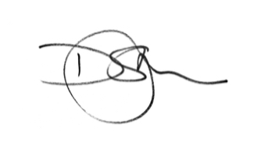
Signed

David St.John-Claire FIOD
CEO Aardvark Group and Aardvark Clear Mine Ltd

www.aardvark.group
Aardvark & The Aardvark Group are trading styles of Aardvark Clear Mine Limited Registration No:- 80167, VAT Reg. No:- 281 9081 87
Page 1 of 1

